1. Consider a system with 4 processes and 3 resources with the given resource matrices.

Claim matrix Allocation matrix

3 2 2 1 0 0

6 1 3 6 1 2

3 1 4 2 1 1

4 2 2 0 0 2

The resource vector is [9,3,6]. Write a C program to determine if the system is in safe or unsafe state.

Program:

#include<stdio.h>

int main()

{

int claim[4][3]={{3,2,2},{6,1,3},{3,1,4},{4,2,2}};

int allo[4][3]={{1,0,0},{6,1,2},{2,1,1},{0,0,2}};

int res[3]={9,3,6};

int ava[3]={0,0,0};

for(int j=0;j<3;j++){

for(int i=0;i<4;i++){

ava[j]=allo[i][j];

}

ava[j]=res[j]-ava[j];

}

int finish[4]={0,0,0,0};

int safe_seq[4];

int num_fin=0;

while(num_fin<4){

int safe_found=0;

for(int i=0;i<4;i++){

if(!finish[i]){

int can_finish=1;

for(int j=0;j<3;j++){

if(claim[i][j]-allo[i][j]>ava[j]){

can_finish=0;

break;

}

}

if(can_finish){

safe_seq[num_fin]=i;

num_fin++;

finish[i]=1;

for(int j=0;j<3;j++){

ava[j]+=allo[i][j];

}

safe_found=1;

}

}

}

if(!safe_found){

break;

} }

if(num_fin==4){

printf("safe sequence:");

for(int i=0;i<4;i++){

printf("%d",safe_seq[i]);

}

printf("\n the system is in asafe.\n");

}else{

printf("\n the syastem is in an unsafe state\n");

}

return 0;

}

Output:

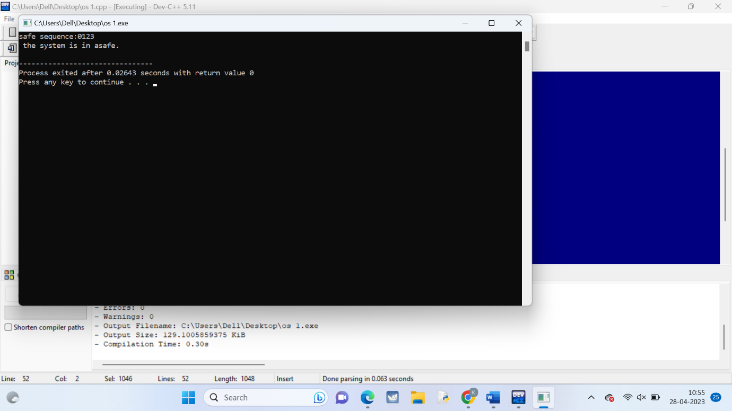

1. 2. Write a C program to illustrate the FIFO method of page replacement and determine the number of page faults for the following test case:

No of page frames: 3; Page reference sequence: 4, 1, 2, 4, 3, 2, 1 and 5.

Program:

#include<stdio.h>

int main()

{

int n,frames[10],page[30],page_fault=0,first=0,last=0,found=0;

printf("enter the number of page frame:");

scanf("%d",&n);

printf("enter the page reference sequence:");

for(int i=0;i<8;i++)

{

scanf("%d",&page[i]);

}

for(int i=0;i<n;i++)

{

frames[i]=-1;

}

for(int i=0;i<8;i++){

found=0;

for(int j=0;j<n;j++){

if(frames[j]==page[i])

{

found=1;

break;

}

}

if(found==0){

page_fault++;

frames[last]=page[i];

last=(last+1)%n;

}

printf("\n%d\t",page[i]);

for(int j=0;j<n;j++){

printf("\n%d\t",page[i]);

}

}

printf("\n number of page fault=%d",page_fault);

return 0;

}

Output:

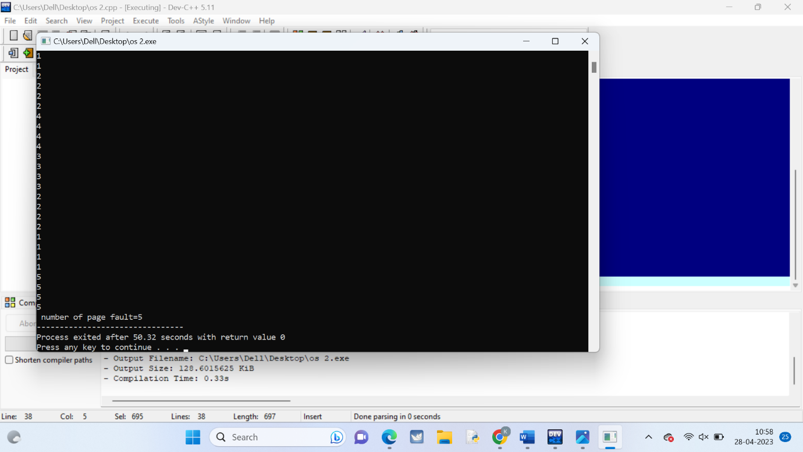

1. 3. Write a program to compute the average waiting time and average turnaround time based on Non Preemptive Shortest-Job-First Scheduling for the following process with the given CPU burst times, ( and the assumption that all jobs arrive at the same time.)

Process Burst Time

P1 6

P2 8

P3 7

P4 3

Program:

#include<iostream>

int main(){

int n=4;

int bt[]={6,8,7,3};

int p[]={1,2,3,4};

int wt[n],tat[n],total_wt=0,total_tat=0;

for(int i=0;i<n;i++){

for(int j=i+1;j<n;j++){

if(bt[i]>bt[j]){

int temp_bt=bt[i];

bt[i]=bt[j];

bt[j]=temp_bt;

int temp_p=p[i];

p[i]=p[j];

p[j]=temp_p;

}

}

}

wt[0]=0;

for(int i=1;i<n;i++){

wt[i]=wt[i-1]+bt[i-1];

}

for(int i=0;i<n;i++){

tat[i]=bt[i]+wt[i];

}

printf("process burst time waiting time turnaround time\n");

for(int i=0;i<n;i++){

total_wt+=wt[i];

total_tat+=tat[i];

printf("p%d\t\t%d\t\t%d\t\t%d\n",p[i],bt[i],wt[i],tat[i]);

}

printf("n average waiting time=%2f\n",(float)total_wt/n);

printf("average turnaround time=%2f\n",(float)total_tat/n);

return 0;

}

Output:

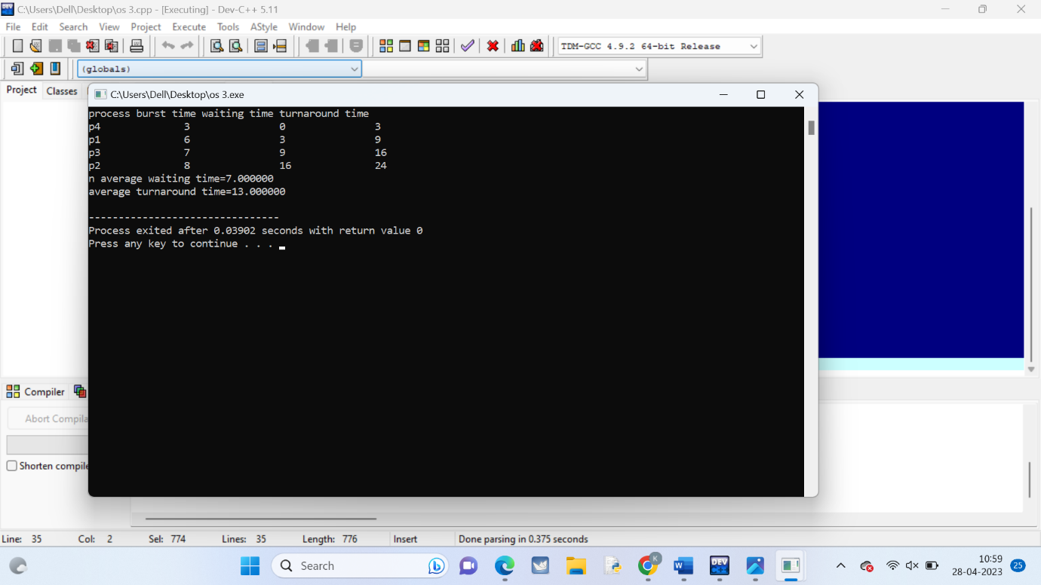

1. 4. Write a C program to implement the first-fit algorithm for memory management.

Test Case:

Memory partitions: 300 KB, 600 KB, 350 KB, 200 KB, 750 KB, and 125 KB (in order) Show the outcome for the test case with first-fit algorithms to place the processes of size 115 KB, 500 KB, 358 KB, 200 KB, and 375 KB (in order)

Program:

#include <stdio.h>

int main() {

int memory[] = {300, 600, 350, 200, 750, 125};

int n = sizeof(memory)/sizeof(memory[0]);

int process[] = {115, 500, 358, 200, 375};

int m = sizeof(process)/sizeof(process[0]);

int allocation[m];

for (int i = 0; i < m; i++)

allocation[i] = -1;

for (int i = 0; i < m; i++) {

for (int j = 0; j < n; j++) {

if (memory[j] >= process[i]) {

allocation[i] = j;

memory[j] -= process[i];

break;

}

}

}

printf("Process No.\tProcess Size\tAllocated Block No.\n");

for (int i = 0; i < m; i++) {

printf("%d\t\t%d KB\t\t", i+1, process[i]);

if (allocation[i] != -1)

printf("%d\n", allocation[i]+1);

else

printf("Not Allocated\n");

}

return 0;

}

Output:

